Name:Arivalagan S/O Sivasankaran

Ct Number:CT0345541

Lecturer Name:Kang Leng

GitHub Address: <https://github.com/ARI021102/ari_cmca_assignment.git>

**Question 1**

(a) Convert the 345 decimal number to

1. (i) Binary
2. Remainder
3. 2 | 345 1
4. 2 | 172 0
5. 2 | 86 0
6. 2 | 43 1
7. 2 | 21 1
8. 2 | 10 0
9. 2 | 5 1
10. 2 | 2 0

1

Ans: 0000 0001 0101 1001

1. (ii) Octal
2. Remainder
3. 8 | 345 1
4. 8 | 43 3

5

Ans: 531

(iii) Hexadecimal

Remainder

1. 16 | 345 9
2. 16 | 21 5

1

Ans: 0×159

(b) Calculate the following

1. (i) 4568 + 7468

1 1

4 5 6 68 + 68 = 14(1,2,3,4,5,6,7,10,11,12,13,14)

+ 7 4 6 58 + 48 + 18 = 12(1,2,3,4,5,6,7,10,11,12,13,14)

---------------- 78 + 48 + 18 = 14(1,2,3,4,5,6,7,10,11,12,13,14)

1 4 2 4

Ans:1424

1. (ii) 10112 * 1012
2. 10112 * 1012 = 110111

1 0 1 1

x 1 0 1

----------------

1 0 1 1

0 0 0 0

1 0 1 1

----------------------------

1. 1 0 1 1 1
2. Ans: 0011 0111(8Bits)
3. 0000 0000 0011 0111(16Bits)
4. (iii) F6B16 + BCE16

1 1

F 6 B16

+B C E16

----------------

1 B 3 9

B+E=11+14=25

25-16=9 Therefore 25 is 0x19

1+6+C=1+6+12=19

19-16=3 Therefore 19 is 0x13

1+F+B=1+15+11=27

27-16=11 Therefore 27 is 0x11

Ans:1B39

**Q2**

**i)**

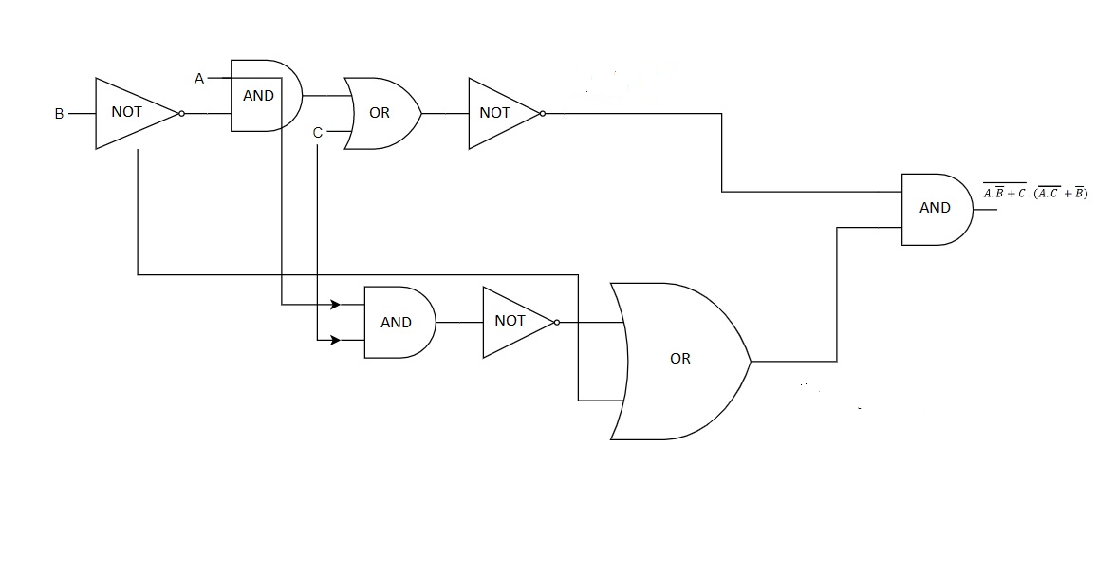

**ii)**

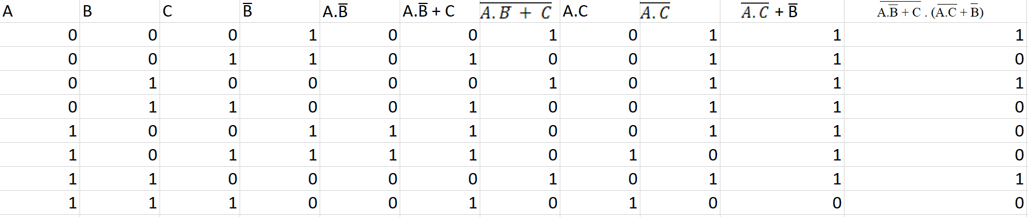

**iii)**

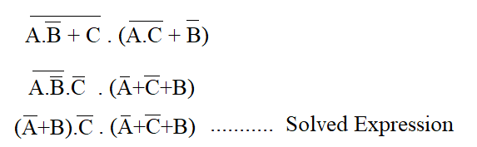

Question 3

(a)

frequency = [440.0 493.9 523.2 587.3 659.3 698.5 784.0];

wavelength = [0.7800 0.6949 0.6559 0.5843 0.5206 0.4914 0.4378 ]

reciprocal = []

for i=1:length(wavelength)

reciprocal =[reciprocal,1/wavelength(i)]

end

plot(reciprocal,frequency);

xlabel('Wavelength')

ylabel('Frequency')

legend({'Frequency vs Wavelength'},'Location','southeast')

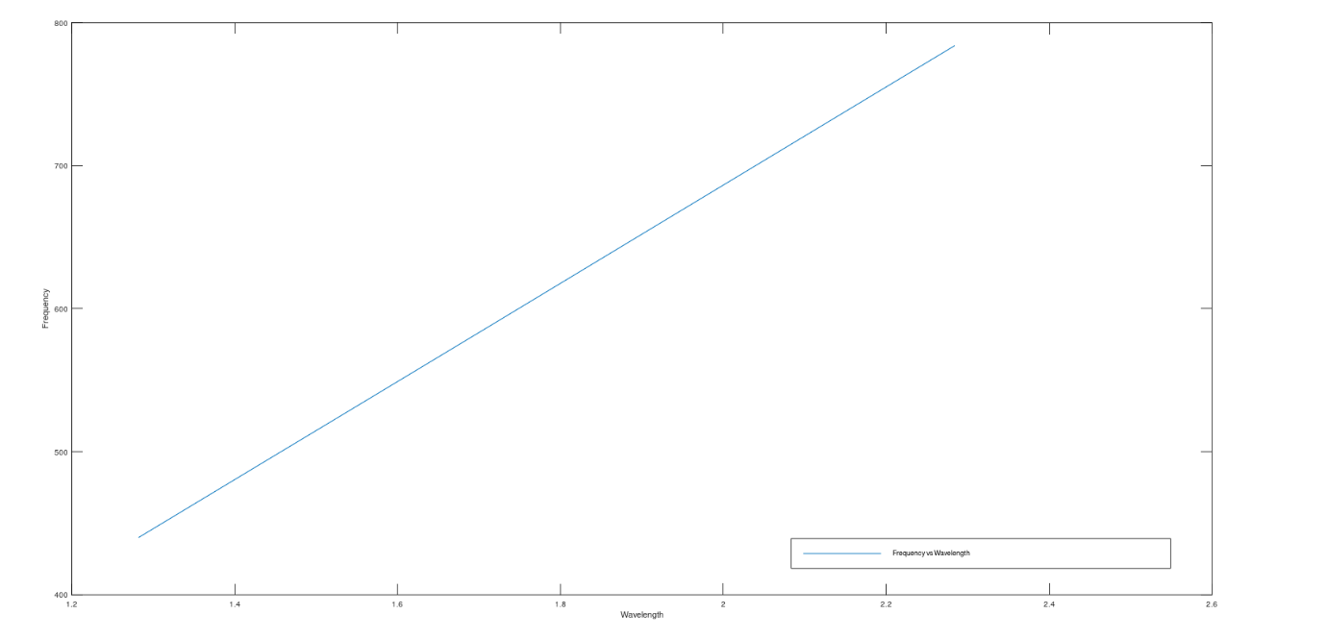

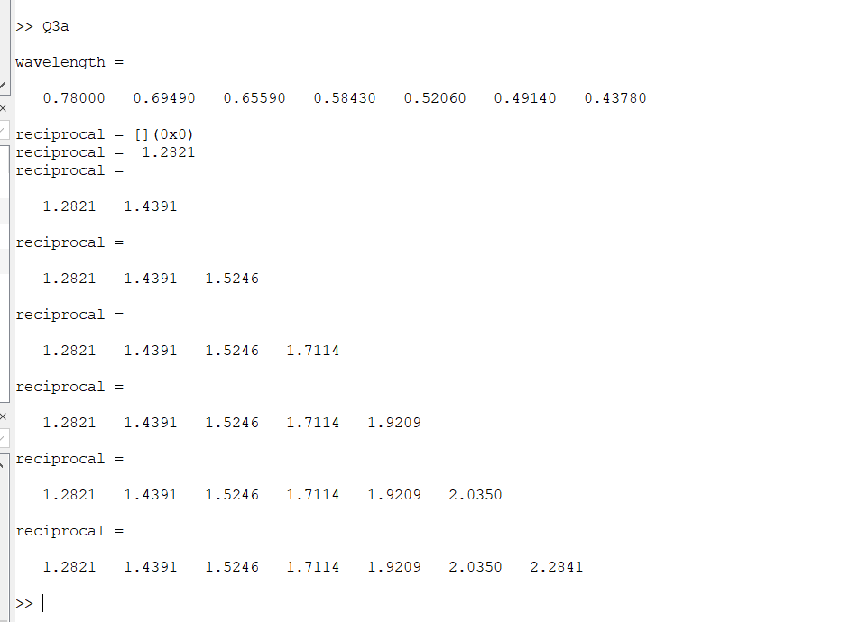

(b)

radius=input('Enter the radius of circular track : ');

gravity=9.8;

minimum_speed= sqrt(gravity*radius);

disp(minimum_speed);

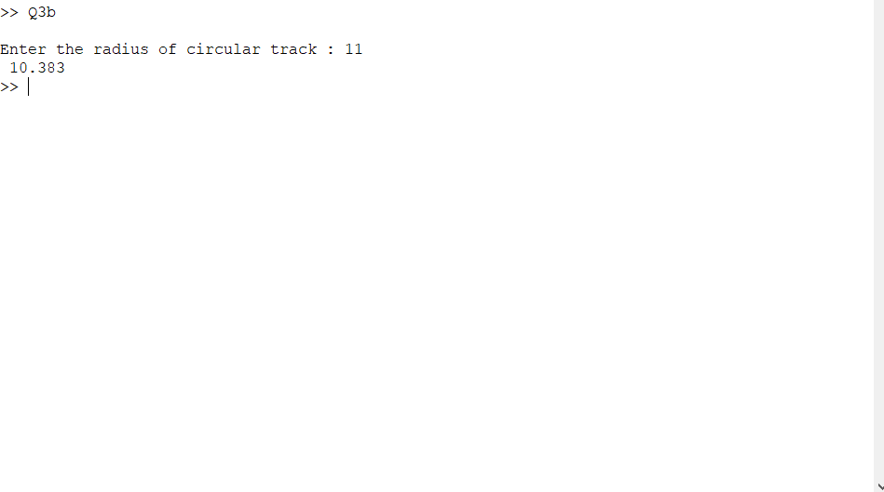

Q4(a)

choice = input('Select Your choice (DR or RD) : ','s');

while choice != 'RD' && choice!='DR'

disp('You Have Entered Wrong Keyword');

choice = input('Select Your choice (DR or RD) : ','s') ;

end

if choice == 'DR'

angle_in_degree = input('Please input Angle in degrees : ');

while isempty(angle_in_degree)

angle_in_degree = input('Please input Angle in degrees : ');

end

angle_in_radian = angle_in_degree*pi/180;

disp('The Angle in radian is : ');

disp(angle_in_radian);

end

if choice == 'RD'

angle_in_radian = input('Please input Angle in radian : ');

while isempty(angle_in_radian)

angle_in_radian = input('Please input Angle in radian : ');

end

angle_in_degree = angle_in_radian*180/pi;

disp('The Angle in Degrees is : ');

disp(angle_in_degree);

end

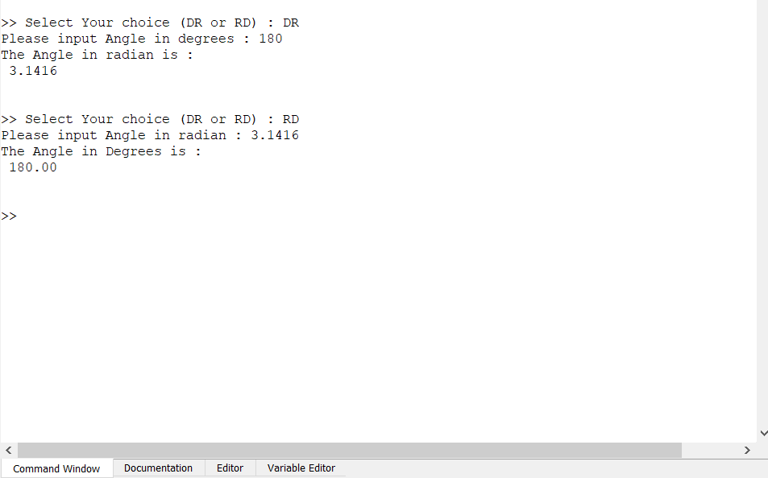

Q5(a)

question = 'Enter the value of N : ';

value_of_n = input(question);

summation = 0;

for i=1:value_of_n

ans1= 1/i;

ans2=(i+2)*(i+3)

ans3= 1/ans2;

summation += ans1+ans3;

end

disp('')

disp(summation);

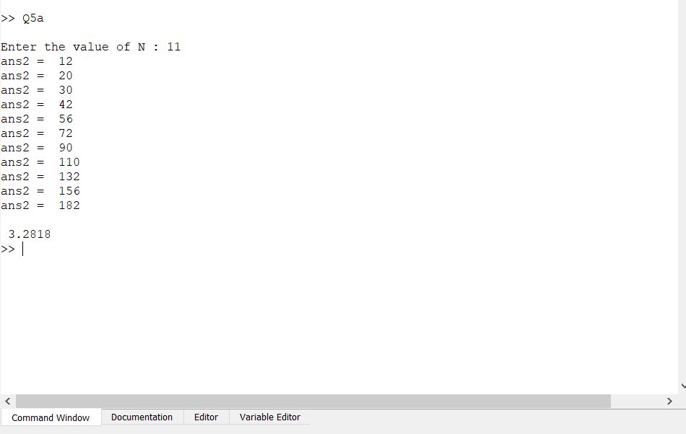

B)

A = $\begin{matrix}-1 & 5 & 2 \\ 3 & -2 & 2\end{matrix}$ B = $\begin{matrix}2 \\ 0 \\ 3\end{matrix}$ C = $\begin{matrix}2 & -1 \\ 3 & 4\end{matrix}$ D = $\begin{matrix}-2 & -0 \\ 4 & -1\end{matrix}$

i) AB $\begin{matrix}-1 & 5 & 2 \\ 3 & -2 & 2\end{matrix}$ X $\begin{matrix}2 \\ 0 \\ 3\end{matrix}$ = $\begin{matrix}4 \\ 12\end{matrix}$

ii) CD $\begin{matrix}2 & -1 \\ 3 & 4\end{matrix}$ X $\begin{matrix}-2 & -0 \\ 4 & -1\end{matrix}$ = $\begin{matrix}-8 & 1 \\ 14 & -5\end{matrix}$

iii) 4(C+D) 4 X ( $\begin{matrix}2 & -1 \\ 3 & 4\end{matrix}$ + $\begin{matrix}-2 & -0 \\ 4 & -1\end{matrix}$) = $\begin{matrix}0 & -4 \\ 28 & 16\end{matrix}$

iv) 5C-3D 5 X $\begin{matrix}2 & -1 \\ 3 & 4\end{matrix}$- 3 X $\begin{matrix}-2 & -0 \\ 4 & -1\end{matrix}$ = $\begin{matrix}16 & -5 \\ 3 & 28\end{matrix}$

v) 2A+DA 2 X $\begin{matrix}-1 & 5 & 2 \\ 3 & -2 & 2\end{matrix}$ + $\begin{matrix}-2 & -0 \\ 4 & -1\end{matrix}$ X $\begin{matrix}-1 & 5 & 2 \\ 3 & -2 & 2\end{matrix}$ = $\begin{matrix}0 & 0 & 0 \\ -1 & 18 & 10\end{matrix}$

Q6

true_condition = true

while true_condition == true

entered_name = input('Enter name : ','s');

entered_address = input('Enter Address : ','s');

entered_amount = input('Enter amount of purchase:')

type_of_purchase = input('Enter Type of Purchase (Laptop(L) or Desktop(D) ) :' ,'s')

if type_of_purchase =='L' || type_of_purchase == 'l'

if entered_amount<=250

discount_given = 0;

end

if entered_amount>250 && entered_amount<=570

discount_given = 0.05*entered_amount;

end

if entered_amount >570 && entered_amount <=1000

discount_given = 0.075*entered_amount;

end

if entered_amount >1000

discount_given = 0.1*entered_amount;

end

net_amount = entered_amount - discount_given;

fprintf('\nName : %s',entered_name);

fprintf('\nAddress : %s',entered_address);

fprintf('\nNet Amount : %f',net_amount);

elseif type_of_purchase == 'D' || type_of_purchase == 'd'

if entered_amount<=250

discount_given = (0.05*entered_amount);

end

if entered_amount>250 && entered_amount<=570

discount_given = 0.075*entered_amount;

end

if entered_amount >570 && entered_amount <=1000

discount_given = 0.1*entered_amount;

end

if entered_amount >1000

discount_given = 0.15*entered_amount;

end

net_amount = entered_amount - discount_given;

fprintf('\nName : %s',entered_name);

fprintf('\nAddress : %s',entered_address);

fprintf('\nNet Amount :%f ',net_amount);

else

disp('Invalid type of purchase')

end

fprintf('\n')

choice = input('Do you wish to continue Purchase?','s');

if choice == 'Y' || choice == 'y'

true_condition = true;

else

true_condition = false;

fprintf('\n')

disp('You have exit purchase screen, Goodbye.')

end

end

